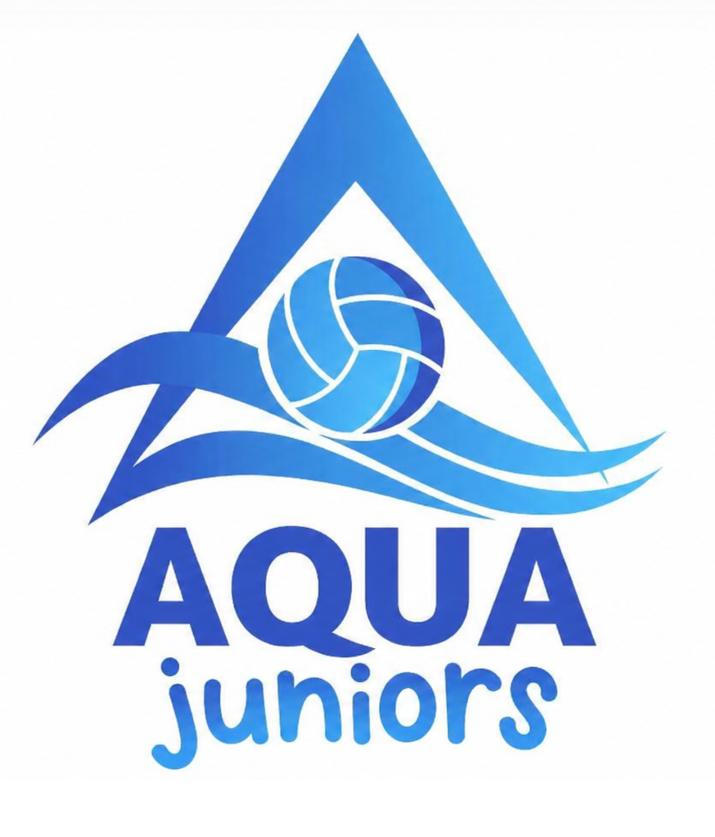

AQUA JUNIORS NETBALL CLUB

Safeguarding Policy Statement

1. Purpose and Scope

Aqua Juniors Netball Club acknowledge its duty of care to safeguard the welfare of all children, young people, and adults at risk participating in netball. This policy applies to all members, staff, volunteers, parents and participants involved in our activities.

2. Core Principles

- Welfare is Paramount: The safety and wellbeing of the individual is the primary consideration in all netball activities.
- Equality and Inclusion: All participants, regardless of age, disability, gender, race, religion, or sexual orientation, have an equal right to protection from harm.
- Shared Responsibility: Safeguarding is everyone’s responsibility. All members are expected to act appropriately and report concerns.

3. Key Requirements

- Club Safeguarding Officer (CSO): We have appointed a designated CSO who is the first point of contact for all concerns.

  - Name: Kelly Warren
  - Phone: 07786437178
  - Email: aquajuniorsnetball@outlook.com

- Safe Recruitment: All staff and volunteers in "regulated activity" will undergo an Enhanced Disclosure and Barring Service (DBS) check through England Netball every three years.

- Training: The CSO and relevant coaches will complete England Netball-approved safeguarding training, every three years

- Codes of Conduct: All participants, parents, and coaches must sign and abide by the England Netball Codes of Conduct.

4. Reporting Procedures

All allegations or concerns of poor practice and abuse will be taken seriously and responded to swiftly in accordance with the England Netball Reporting a Safeguarding Concern Procedure, as follows;
- Report to CSO: Concerns should be reported to the Club Safeguarding Officer immediately.
- England Netball Referral: If the concern relates to potential abuse, the CSO will notify the England Netball Lead Safeguarding Officer at besafe@englandnetball.co.uk.
- Emergencies: In cases of immediate danger, contact the Police (999) or local Children’s/Adult Social Care services. Aqua Juniors will always act in the best interest of the child, and put their needs first.
- Responsible Local Authorities - Lewisham 0208 314 6000 (training venue in Lewisham) Bromley (match play in Bromley) 0208 464 3333

5. Supporting Policies

This statement is supported by our full adherence to:
- England Netball Safeguarding Young People Policy.
- England Netball Safeguarding Adults at Risk Policy.
- England Netball Social Media Policy.

Date Adopted: 02 April 2026
Review Date: 02 April 2027
Responsible Person: Kelly Warren
Signed:

